भारत मौसम विज्ञान विभाग |  | India Meteorological Department
Friday 08th May 2026 (18th Vaisakha 1948 Saka)
Summary of observations recorded at 0830 hours IST: The Western disturbance as a cyclonic circulation over northwest Uttar Pradesh and adjoining Uttarakhand between 5.8 km and 7.6 km above m. s. l. persisted. The upper air cyclonic circulation over central Pakistan & adjoining Punjab and Rajasthan extended upto 1.5 km above m. s. l. persisted. A trough ran from the upper air cyclonic circulation over central Pakistan & adjoining Punjab and Rajasthan to northwest Bangladesh across Haryana, upper air cyclonic circulation over southwest Uttar Pradesh & neighbourhood, Uttar Pradesh, Bihar, Sub-Himalayan West Bengal & Sikkim at 1.5 km above m. s. l. The trough/Wind discontinuity from cyclonic circulation over southeast Arabian Sea and adjoining Lakshadweep off south Kerala to southwest Madhya Pradesh ran from Comorin area to southwest Madhya Pradesh across Vidarbha, Marathwada, Interior Karnataka, Rayalaseema and Tamil Nadu at 0.9 km above m. s. l. An upper air cyclonic circulation lay over southwest Uttar Pradesh & neighbourhood at 0.9 km above m. s. l. The trough from central parts of south Madhya Pradesh to Jharkhand ran from the upper air cyclonic circulation over southwest Uttar Pradesh & neighbourhood to north interior Odisha across East Madhya Pradesh and Chhattisgarh at 0.9 km above m. s. l. The upper air cyclonic circulation over central Assam & neighbourhood extending upto 1.5 km above m. s. l. persisted. An upper air cyclonic circulation lay over south Andaman Sea & neighbourhood extended upto 1.5 km above m. s. l. A trough in westerlies between 5.8 km & 7.6 km above m. s. l. ran roughly along Long. 83°E to the north of Lat. 18°N. A fresh Western Disturbance is likely to affect Western Himalayan Region from 10th May, 2026. The upper air cyclonic circulation over southeast Arabian Sea and adjoining Lakshadweep off south Kerala coast became less marked. The upper air cyclonic circulation over north Haryana & neighbourhood became less marked. The upper air cyclonic circulation over interior Odisha and adjoining Chhattisgarh became less marked. The upper air cyclonic circulation over east Bihar became less marked. The upper air cyclonic circulation over Central Parts of South Madhya Pradesh & neighbourhood became less marked at 0530 hrs IST of today morning.
Maximum Temperature Departures (as on 07-05-2026): markedly above normal (> 5.1°C) at many places over West Rajasthan; at few places over Jammu-Kashmir-Ladakh-Gilgit-Baltistan-Muzaffarabad; at isolated places over East Rajasthan, Saurashtra & Kutch and Chhattisgarh. appreciably above normal (3.1°C to 5.0°C) at most places over Gujarat Region; at few places over Arunachal Pradesh and Assam & Meghalaya; at isolated places over Himachal Pradesh, West Madhya Pradesh, East Madhya Pradesh, Coastal Andhra Pradesh & Yanam and Telangana. above normal (1.6°C to 3.0°C) at few places over Sub Himalayan West Bengal & Sikkim, Konkan & Goa, Vidarbha and Lakshadweep; at isolated places over Odisha, Haryana-Chandigarh-Delhi, Punjab, Madhya Maharashtra, Marathwada and Tamil Nadu, Puducherry & Karaikal. near normal (-1.5°C to 1.5°C) at many places over Rayalaseema, Coastal Karnataka, North Interior Karnataka, South Interior Karnataka and Kerala & Mahe; at most places over Andaman & Nicobar Islands; at few places over Nagaland, Manipur, Mizoram & Tripura and Jharkhand; at isolated places over Bihar, East Uttar Pradesh and West Uttar Pradesh. The highest maximum temperature of 42.8°C was reported at Phalodi-Obs (Rajasthan).
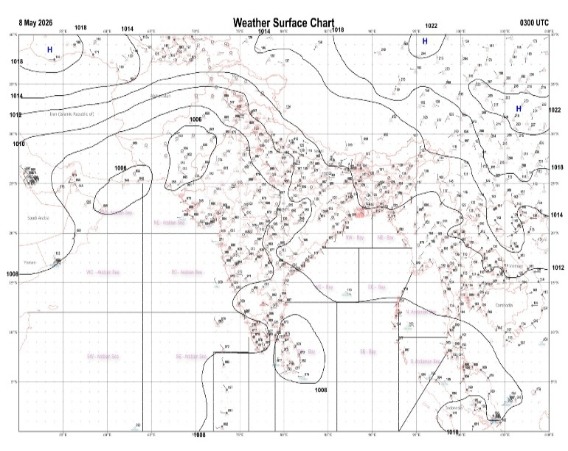 | 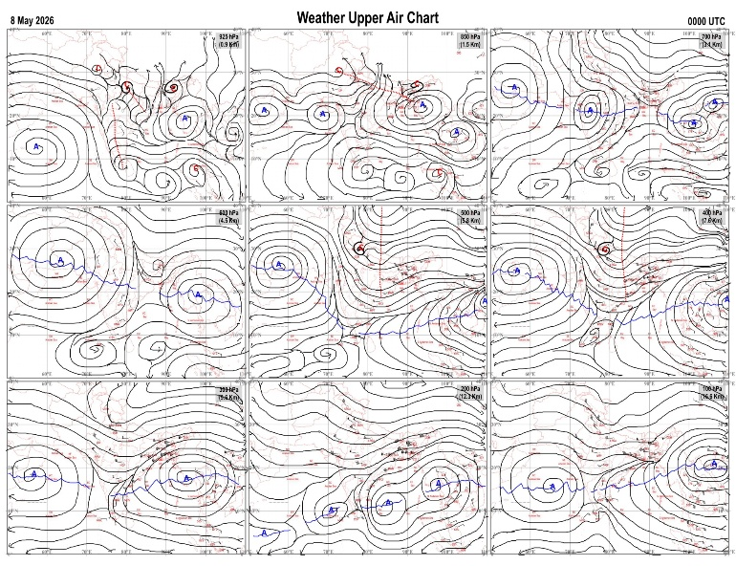
Fig.1. Analysed surface chart based on 03z observation | Fig.2. Analysed upper air chart based on 00z observation
V.K.Shripad
Scientific Officer ‘I’
CR & S Office, Pune  Issued at 1245 hrs. IST |  | Weather Forecasting Division  CR&S, Pune

Indian regions | Realised rainfall (chief amount in cm during past 24 hrs):
East | many places: West Bengal & Sikkim  isolated places: Arunachal Pradesh, Assam & Meghalaya, Nagaland-Manipur-Mizoram-Tripura, Odisha, Jharkhand and Bihar  Gairkata tea estate & Nayagarh 5.6 each, Thakurganj 5.4, Odagaon 5.3, Gopalpur tea estate 5.1, Alipore 4.9, Tuting & Koner dvc 4.4 each, Koner 4.3, Palasi 4.2, Lalgarh 3.2, Amta 2.6, Jorhat 2.1, Jiribam AWS & Chandbali 1.9 each, Jalpaiguri & Forbesganj 1.5 each, Kohima & Mokokchang 1.2 each, Badarpur ARG & Barapani 1.0 each, Bomdila AWS 0.9, Daparijo 0.7, Daltonganj 0.2.
North | isolated places: Uttar Pradesh, Uttarakhand, Haryana◆, Punjab◆, Himachal Pradesh, Jammu-Kashmir and Ladakh and east Rajasthan  dry weather: west Rajasthan  Dausa 2.5, Didihat 2.1, Regoli & Garotha 2.0 each, Maharajganj 1.8, Sarahan 1.5, Budaun & Dwarhat 1.4 each, Mainpuri 1.0, Mukteshwar 0.8, Nainwa 0.7, Banda 0.6, Rohru 0.5, Raj pura ARG & Sawaimadhopur tesil SR 0.3 each, Mahendragarh AWS, Anandpur sahib, Bhaderwah ARG & Bandipora AWS 0.1 each.
Central | isolated places: Madhya Pradesh, Vidarbha and Chhattisgarh  Yeotmal 2.1, Badarwas 1.6, Patharia & Majhgaon 1.2 each, Ghatigaon 0.9, Ambikapur 0.7, Nagpur aerodrome 0.6, Sheopur-aws, Damoh-aws, Umrer & Bilaspur 0.3 each, Lalpur thana 0.2.
Peninsula | many places: Kerala+  a few places: Tamil Nadu+++ and north interior Karnataka  isolated places: Gujarat Region, Konkan & Goa, Madhya Maharashtra, Marathwada, coastal Andhra Pradesh, Telangana, Rayalaseema◆ and coastal and south interior Karnataka  dry weather: Saurashtra & Kutch  Kulithalai ARG 14.0, Kulithalai 9.8, Thodupuzha 8.5, Udupi 6.2, Jalahalli 6.0, Erode 5.4, Neryamangalam ARG 5.3, Kammar palle 4.5, Shorapur 4.3, Manuguru 4.2, Trivandrum AP 3.3, Poladpur & Tiptur 3.0 each, Valod & Kankavli 2.8 each, Karkala 2.0, Mangalagiri 1.8, Rampura 1.6, Igatpuri & Amaravati 1.5 each, Shahuwadi & Shivamogga PTO 1.4 each, Bhadrachalam 1.3, Belagavi AP 0.9, Hadgaon 0.7, Matheran & Udgir IMD parttime 0.3 each, Ardhapur 0.2, Sangli , Vijayawada AP, Devanakonda & Venkatagiri 0.1 each.
Islands | many places: Lakshadweep  isolated places: Andaman & Nicobar  Minicoy 1.7, Maya bandar 1.1, Agathi 0.3.
Table-2 Forecast / warnings (distribution of rain / thundershowers) for 7 days (valid from time of origin upto 0830 hrsIST of next day)
Sr N. |  | Sub-division Name | Day 1 | Day 2 | Day 3 | Day 4 | Day 5 | Day 6 | Day 7 | Sr. No. | Sub-division Name | Day 1 | Day 2 | Day 3 | Day 4 | Day 5 | Day 6 | Day 7
 |  |  | 08 May | 09 May | 10 May | 11 May | 12 May | 13 May | 14 May |  |  | 08 May | 09 May | 10 May | 11 May | 12 May | 13 May | 14 May
 | 1 | Andaman Nicobar Islands | F  | F  | F  | F  | F | F | S | 19 | west Madhya Pradesh | I  | I  | D | D | D | D | D
 | 2 | Arunachal Pradesh | S  | I | I | S | S  | F + | F + | 20 | east Madhya Pradesh | I  | I  | D | D | D | D | D
 | 3 | Assam-Meghalaya | I  | I  | I  | S  | F+ | W + | W + | 21 | Gujarat region | D | D + | D + | D + | D + | D+ | D +
 | 4 | Nagaland-Manipur-Mizoram-Tripura | S  | S  | I  | I  | S  | S | S | 22 | Saurashtra and Kutch | D + | D + | D + | D + | D + | D+ | D+
 | 5 | Sub Him West Bengal/Sikkim | F+●/* | F  | S | I | S | F+●/* | F+●/* | 23 | Konkan and Goa | I+ | I + | I + | D | D | D | D
 | 6 | Gangetic West Bengal | F  | W  | F  | I | I | S | S | 24 | Madhya Maharashtra | I  | I  | I | D | D | D | D
 | 7 | Odisha | I  | I  | I  | I  | I | I | I | 25 | Marathwada | I  | I  | I | D | D | D | D
 | 8 | Jharkhand | I  | S  | S  | I  | I | S | I | 26 | Vidarbha | I  | I  | I  | I | D | D | D
 | 9 | Bihar | S  | F  | I  | I  | I | S | I | 27 | Chhattisgarh | I  | I  | I  | I  | I  | I | I
 | 10 | east Uttar Pradesh | I  | I  | D | D | I | I | I | 28 | Coastal Andhra Pradesh and Yanam | I  | I  | I  | I  | I  | I | I
 | 11 | west Uttar Pradesh | I  | D | D | D | I | I | I | 29 | Telangana | I  | I  | I  | I | D | D | D
 | 12 | Uttarakhand | I  | I | I | S  | F  | F  | S | 30 | Rayalaseema | I  | I  | I  | I | I | I | I
 | 13 | Haryana,Chandigarh and Delhi | D | D | D | I  | I | I | I | 31 | Tamil Nadu, Puducherry and Karaikal | S + | S +  | S + | S+  | S+ | S + | S +
 | 14 | Punjab | D | D | D | I  | I | I | I | 32 | Coastal Karnataka | S  | S  | I | I | I | I | I
 | 15 | Himachal Pradesh | I | D | D | S  | F  | F  | S  | 33 | North interior Karnataka | I  | I  | I  | I  | I  | I | I
 | 16 | Jammu-Kashmir and Ladakh | D | D | I | F  | F  | F | S | 34 | South interior Karnataka | S +  | I +  | I  | I  | S  | I | I
 | 17 | west Rajasthan | D + | D + | I + | D + | D+ | D + | D+ | 35 | Kerala and Mahe | F + | W + | W+ | W + | W+ | W + | W +
 | 18 | east Rajasthan | I  | I | D | D | D | D | D | 36 | Lakshadweep | F  | F +  | F+ | F  | F  | F | F
Legends: D = Dry I =isolated S = Scattered F = Fairly widespread W = Widespread #= heavy to very heavy rain at a few places with extremely heavy rain at isolated places+++= heavy rain at a few places with very heavy rain at isoIated places++= heavy to very heavy rainfall @=isolated exceptionally heavy rainfall+ = heavy rain ●/*= rain or snow ♦ = very light rain ≡=fog = thunderstorm with lightning =Squall / Gusty / gale / strong wind -=cold wave/cold day + = heat wave/warm night/hot and humid weather =Duststorm =ground frost = Hail.

Fig. 4: Districtwise warnings for five days for Maharashtra State
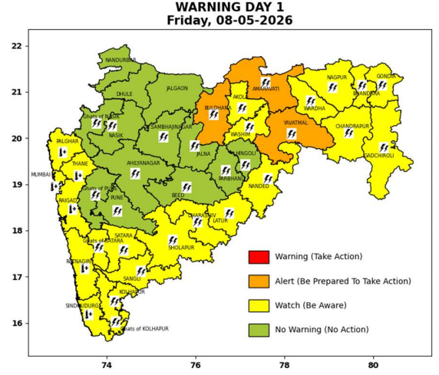 | 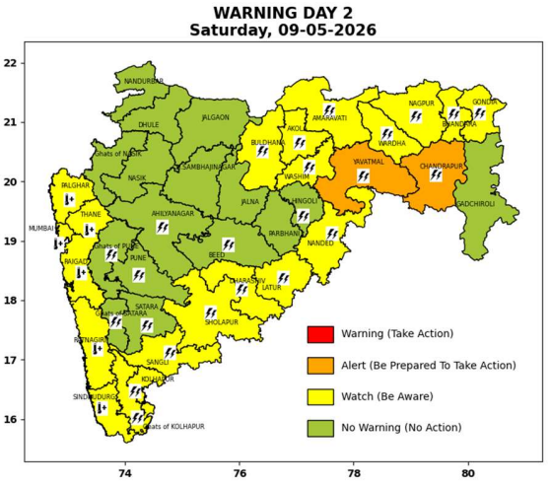 | 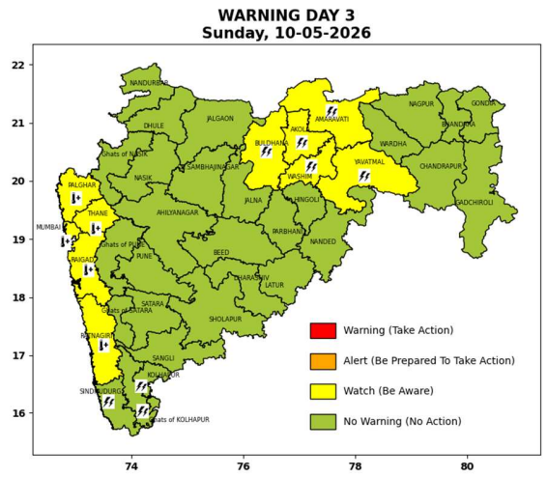 | 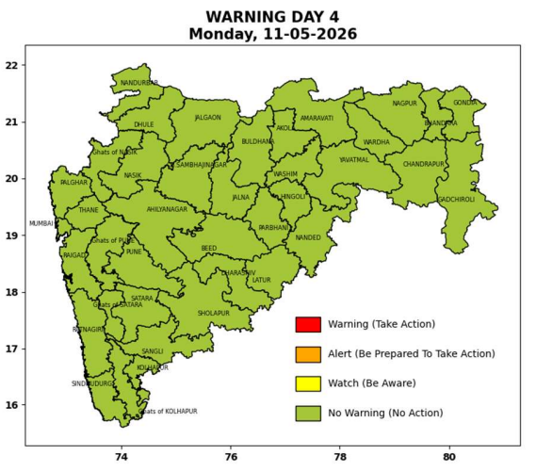 | 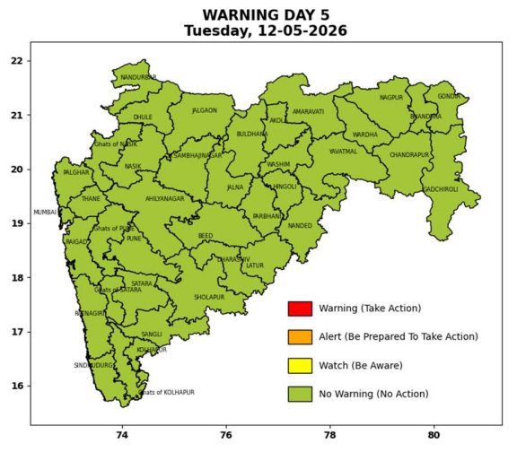

Pune, Lohegaon and Pashan observations at 0830 hrs. IST of Today
 | Temperature (°C) |  |  |  |  | Humidity (%) |  |  |  | Rainfall (mm)
 | Max.  past  24 hrs | Dep.  from  normal | Min.  past  24 hrs. | Dep.  from  normal | Dry  Bulb | At 0830 hrs. IST | Dep.  From  normal | At 1730  hrs. IST of y’day | Dep.  from  normal | Past  24 hrs. | Since  1st March | Dep.  from  normal
PNE | 39.6 | 1.6 | 23.7 | 1.1 | 28.8 | 58 | 2 | 48 | 16 | 0.0 | 92.8 | 73.7
PSN | - | - | - | - | - | - | - | - | - | - | - | -
LHG | 40.9 | 2.9 | 26.7 | 5.7 | 31.4 | 38 | -17 | 26 | -4 | 0.0 | 91.4 | 67.9

 |  |  |  |  |  |  | Local (Pune and neighbourhood) forecast
Max./Min. Temperature (°C) |  |  |  |  |  |  |  |  | Weather
Date | Pune | Pashan | Lohegaon | Chinchwad | Lavale | Magarpatta | NDA | Koregoan park
08/05/26 | 39 / 23.7* | 38 / - | 41 / 26.7* | 39 / - | 37 / 22.6* | 38 / 27.9* | 37 / 23.3* | 40 / 26.9* | Mainly clear sky becoming partly clear sky towards afternoon or evening.
09/05/26 | 39 / 24 | 38 / 23 | 41 / 27 | 39 / 26 | 37 / 23 | 38 / 28 | 37 / 23 | 40 / 27 | Mainly clear sky becoming partly clear sky towards afternoon or evening.
10/05/26 | 39 / 24 | 38 / 23 | 41 / 27 | 39 / 26 | 37 / 23 | 38 / 28 | 37 / 23 | 40 / 27 | Mainly clear sky becoming partly clear sky towards afternoon or evening.
11/05/26 | 40 / 24 | 39 / 23 | 42 / 27 | 40 / 26 | 38 / 23 | 39 / 28 | 38 / 23 | 41 / 27 | Mainly clear sky becoming partly clear sky towards afternoon or evening.
12/05/26 | 40 / 25 | 39 / 24 | 42 / 26 | 40 / 27 | 38 / 24 | 39 / 28 | 38 / 24 | 41 / 28 | Mainly clear sky becoming partly clear sky towards afternoon or evening.
13/05/26 | 40 / 25 | 39 / 24 | 42 / 26 | 40 / 27 | 38 / 24 | 39 / 28 | 38 / 24 | 41 / 28 | Mainly clear sky becoming partly clear sky towards afternoon or evening.
14/05/26 | 40 / 25 | 39 / 24 | 42 / 26 | 40 / 27 | 38 / 24 | 39 / 28 | 38 / 24 | 41 / 28 | Mainly clear sky becoming partly clear sky towards afternoon or evening.
Rainfall Distribution |  |  |  |  | Rainfall Categories | Rainfall (mm) | Cloud condition |  | Rainfall Intensity | Range
Widespread (W) | 76-100% |  |  |  | Very Light rain | Trace to 2.4 mm | Mainly clear sky | 1-2 oktas | Light Spell | 1 cm/hr
 |  |  |  |  | Light rain | 2.5 to 15.5 mm | Partly cloudy sky | 3-4 oktas | Moderate Spell | 1-2 cm/hr
Fairly Widespread (FW) | 51 – 75% |  |  |  | Moderate rain | 15.6 to 64.4 mm | Generally cloudy sky | 5-7 oktas | Intense Spell | 2-3 cm/hr
Scattered (S) | 26 – 50% |  |  |  | Heavy rain | 64.5 to 115.5 mm | Overcast | 8 oktas | Very Intense Spell | 3-5 cm/hr
Isolated (I) | 1 – 25% |  |  |  | Very heavy rain | 115.6 to 204.4 mm |  |  | Extremely Intense Spell | 5-10 cm/hr
Dry (D) | No Rain |  |  |  | Extremely heavy rain | ≥ 204.5 mm |  |  | Cloudburst | > 10 cm/hr
Probability Terms in %: |  |  |  |  | Heavy snow | 6.5 to 11.5 cms water equivalent of rain
unlikely | < 25 |  |  |  | Very heavy snow | 11.6 to 20.4 cms water equivalent of rain
likely | between 25 50
very likely | between 51 75
most likely | >75
* = realized temperatu
Mumbai (Colaba) |  |  |  | Nagpur (AP)
Date 2026 | T max °C | T min °C | Weather | T max °C | T min °C | Weather
08/05/26 | 34 | 28 | Mainly clear sky. | 40 | 22 | Thunderstorm with rain. Thunderstorm accompanied with lightning & gusty winds(40-50kmph).
09/05/26 | 35 | 29 | Mainly clear sky. Hot and Humid. | 41 | 23 | Thunderstorm with rain. Thunderstorm accompanied with lightning & gusty winds(40-50kmph).
10/05/26 | 34 | 29 | Mainly clear sky. | 42 | 22 | Mainly clear sky.
11/05/26 | 34 | 29 | Mainly clear sky. | 43 | 24 | Mainly clear sky.
12/05/26 | 34 | 28 | Mainly clear sky. | 44 | 24 | Mainly clear sky.
13/05/26 | 34 | 28 | Mainly clear sky. | 44 | 25 | Partly cloudy sky.
14/05/26 | 34 | 28 | Mainly clear sky. | 44 | 25 | Mainly clear sky.

